Lesson 04 Demo 09

Creating an App Service Plan

Objective: To create an App Service Plan

Tools required: Operating system, Region details, Pricing plan for App Service Plan

Prerequisites: An Azure account with an active subscription

Steps to be followed:
- Sign in to the Azure Portal
- Configure the details required and create the App Service Plan
- Monitor the App Service Plan and view all the Apps present in the Plan

Step 1: Sign in to the Azure portal
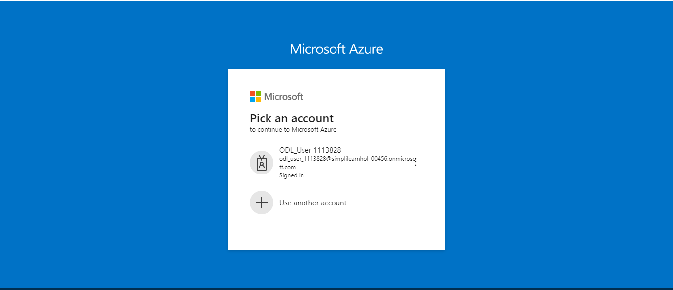

Step 2: Configure the details required and create the App Service Plan

2.1 Click on Create a resource

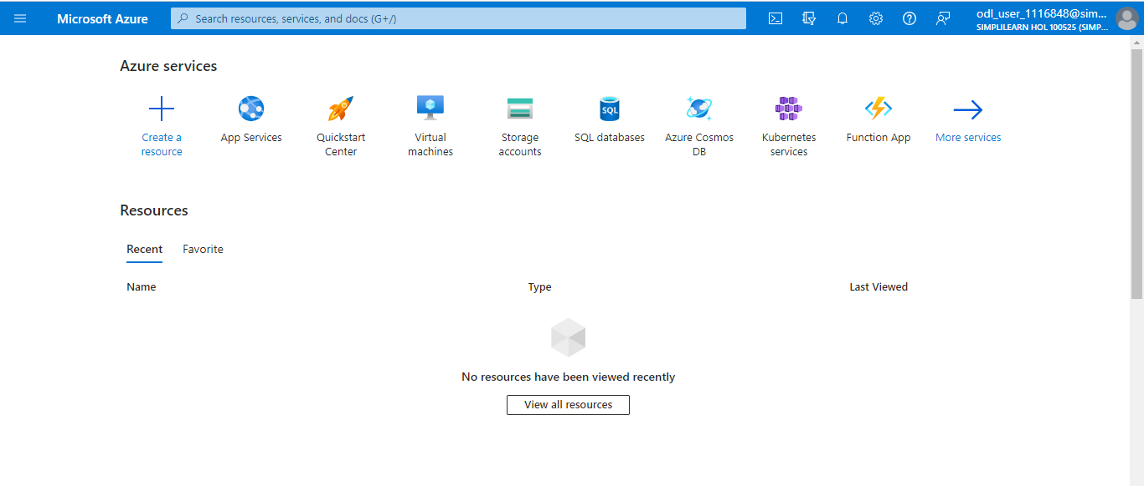

2.2 Search for App Service Plan

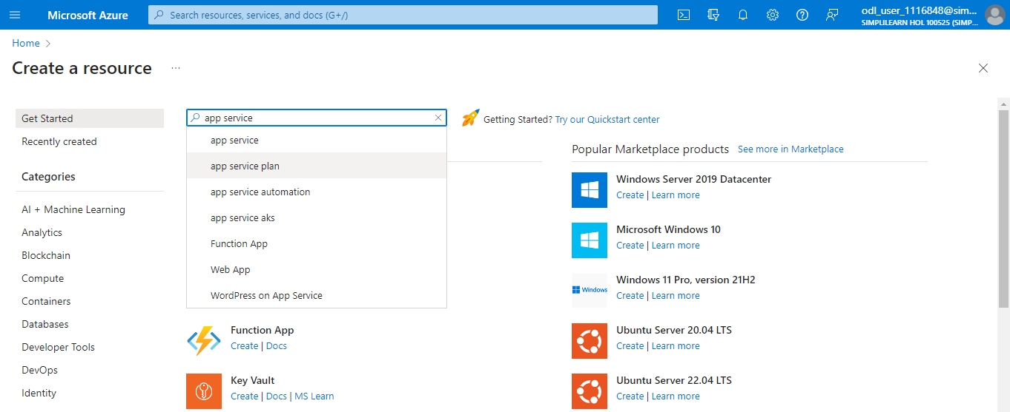

2.3 Click on the Create option under App Service Plan

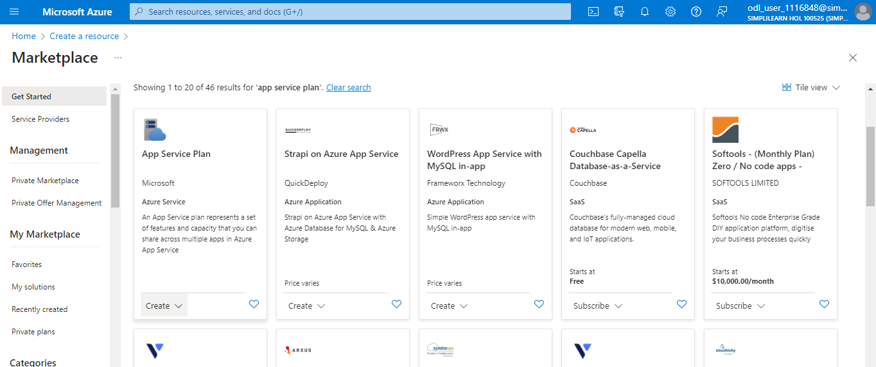

2.4 Configure the Project Details and App Service Plan details. In the App Service Plan details section, name the App Service Plan, then select the Operating System and Region. The Region determines where your App Service Plan is created.

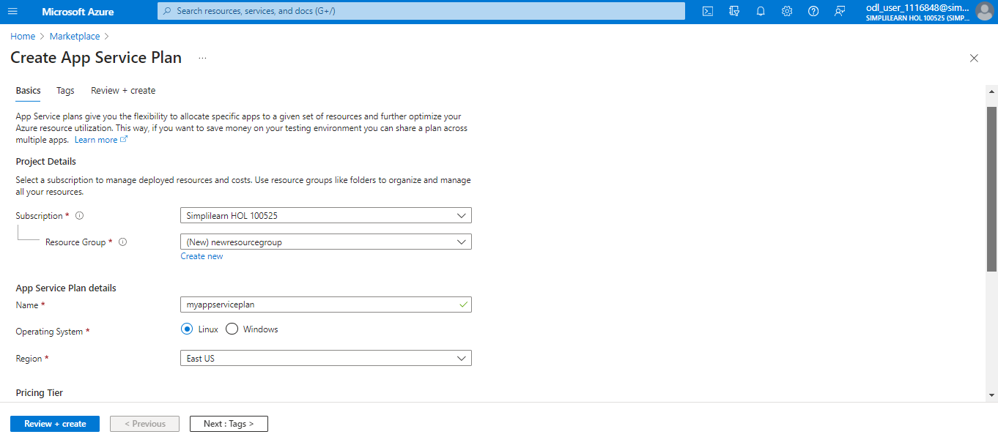

2.5 When creating a plan, you can select the pricing tier of the new plan. In the Pricing Tier, select a pricing plan or select Explore pricing plans to view additional details. You may select the Basic B1 plan. In the Zone redundancy section, select whether the App Service Plan zone redundancy should be enabled or disabled. Select Review + create to create the App Service Plan.

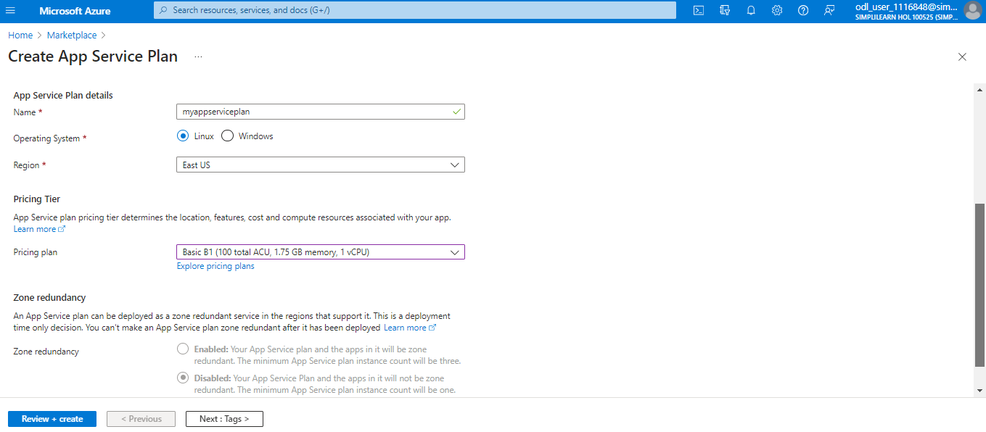

The deployment gets validated as shown below:

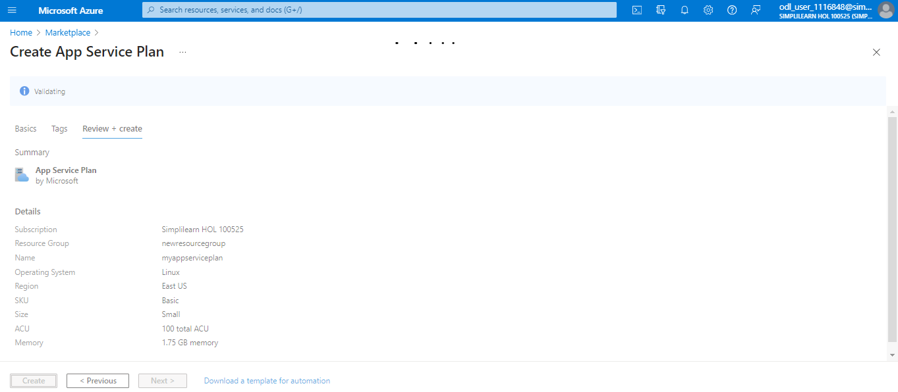

2.6 Click on Create
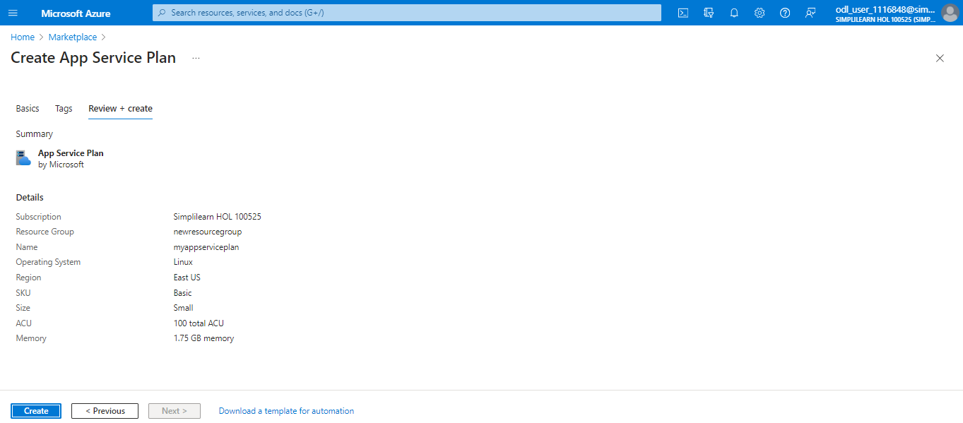
The template deployment gets initialized to the resource group.
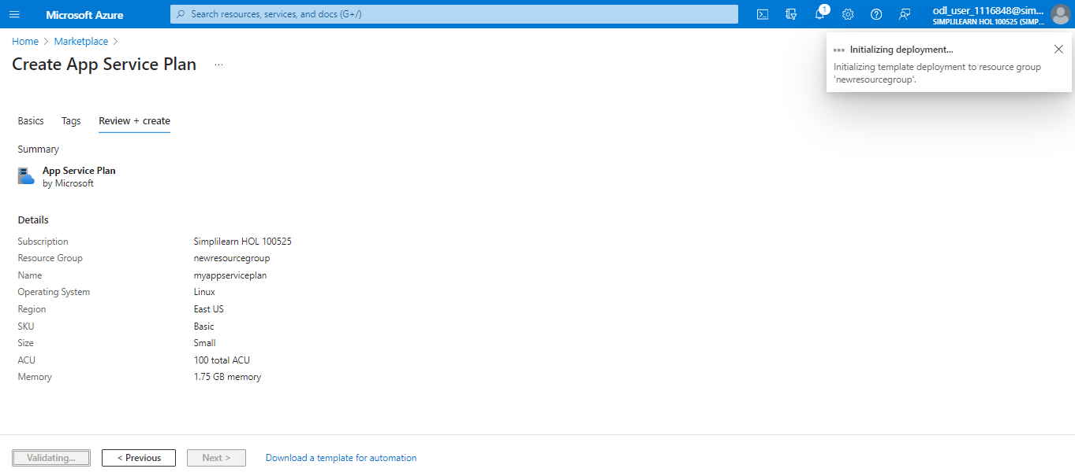

Your deployment is completed.
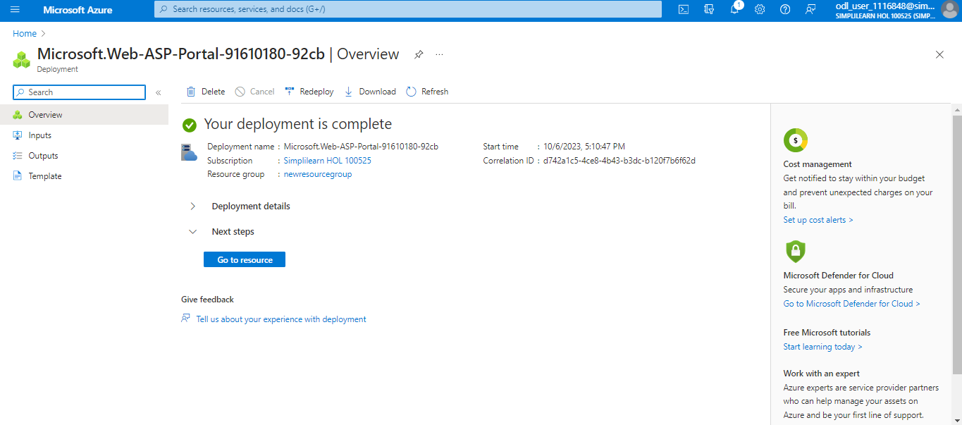
Step 3: Monitor the App Service Plan and view all the Apps present in the Plan
3.1 On the Home page, select the App Service plan type
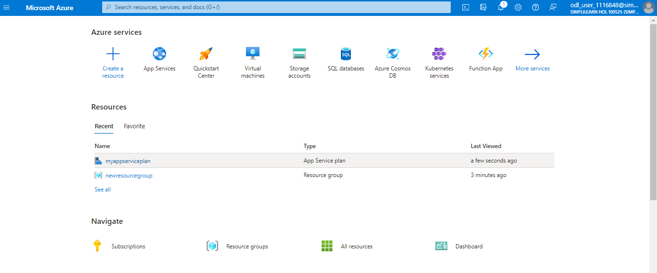

3.2 You can monitor CPU Percentage, Memory Percentage, Data In, and so on.
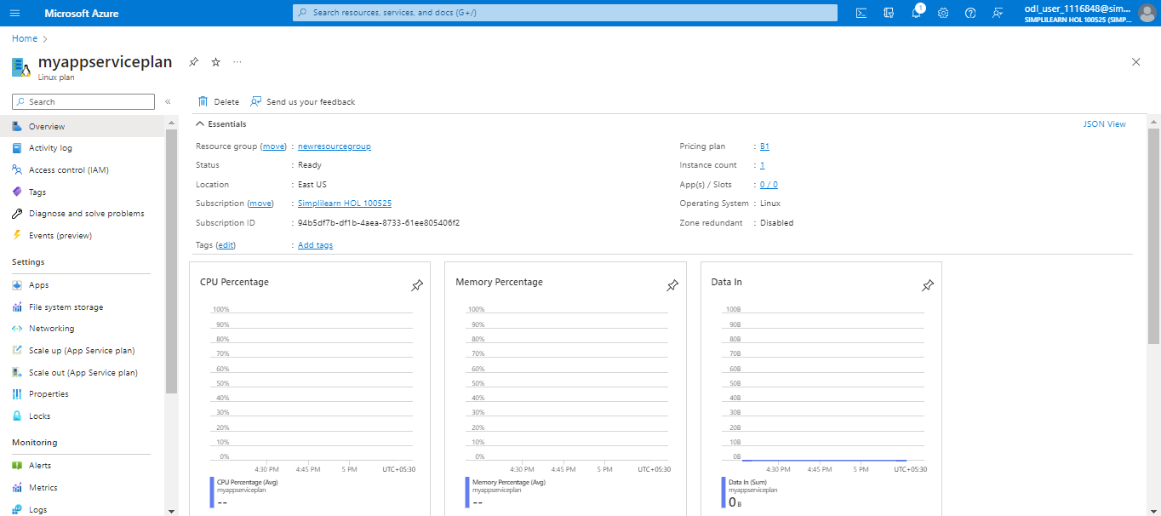
  - You can view all the apps that are present in the selected App Service Plan by navigating to Settings -> Apps
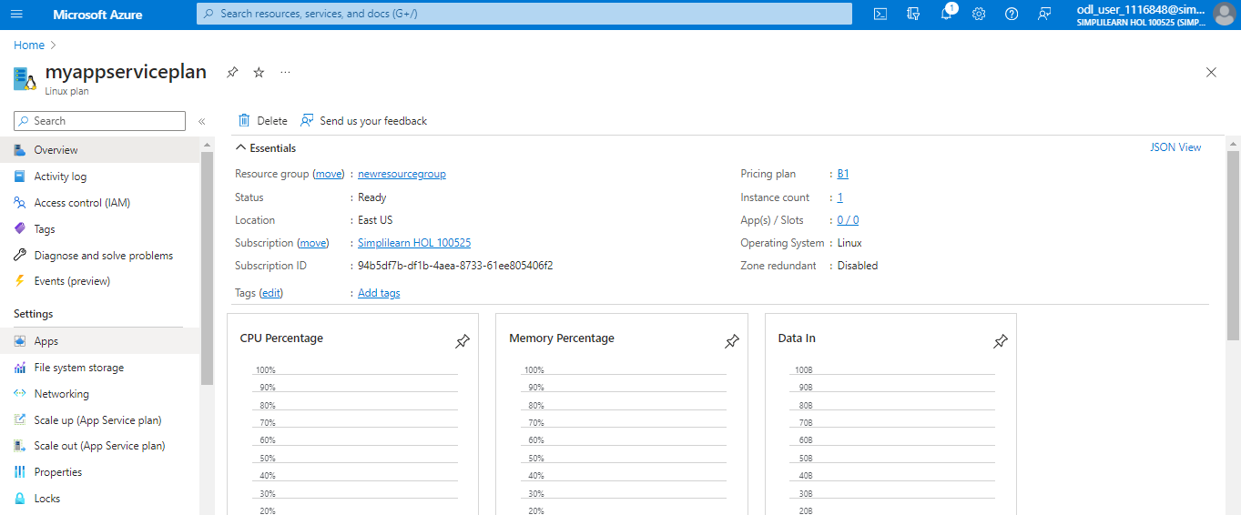
Important Note:
Point 1: When creating a new App Service Plan in an existing Resource Group, certain conditions with existing apps can trigger the following errors:
- The pricing tier is not allowed in this resource group.
- <SKU_NAME> workers are not available in resource group. <RESOURCE_GROUP_NAME>

This can happen due to incompatibilities with pricing tiers, regions, operating systems, availability zones, existing function apps, or existing web apps. If this error occurs, create your App Service Plan in a new Resource Group.
Point 2: Please note that your desired app service should be in the same region as your App Service Plan. If it is not in the same region, you will not be able to list the apps in the respective app service plan.

You have now successfully created an App Service Plan.

